Demonstration that the equals() method finds two students equal if they have the same grades.  
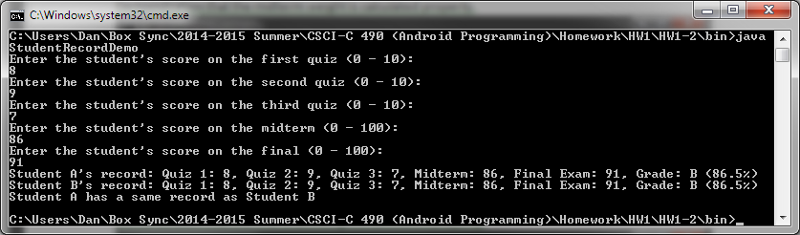

Demonstration that the equals() method finds two students not equal if they have differing grades.  
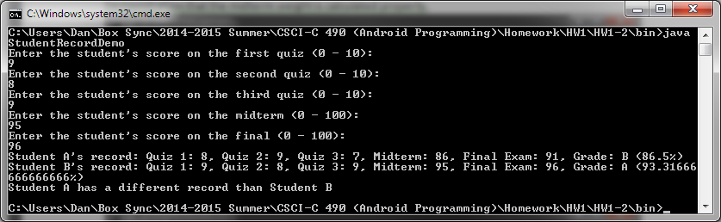

Demonstration that the quiz weight is calculated properly.  
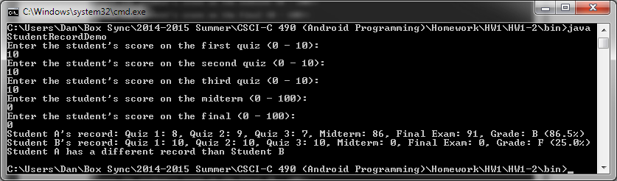

Demonstration that the midterm weight is calculated properly.  
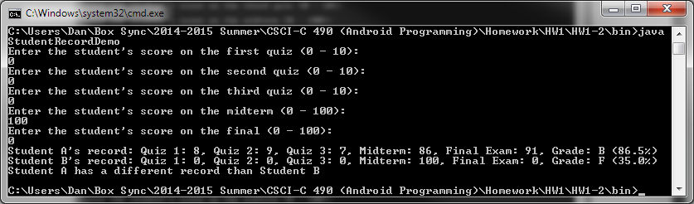

Demonstration that the final exam weight is calculated properly.  
